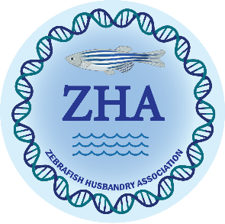

AALAS National Meeting Schedule

Tuesday, November 05, 2024 8:00 – 10:00 AM, Room: 209A

Top-Down: From Regulations to Researcher Compliance in Zebrafish Facilities
Facilitator: Dr. Emma Liechty

Joshua Barber: Welcome and Introductions
8:05 AM Amber Park: Charting Waters: Navigating Regulations in Aquatic Animal Care and Research
8:30 AM Michelle Altemara: Harmonizing Zebrafish Husbandry Parameters: Bridging Gaps in Published Literature
8:55 AM Arrow Megginson: Kraken the Deep Mysteries of Ethics, Husbandry, and Record-keeping of Aquatic Animals
9:20 AM Dante D'India: Swimming Together: Enhancing Communication and Collaboration in Zebrafish Research

Wednesday, November 06, 2024 12:30 – 2:00 PM, Room: 105A

Danio Zoom Live 2: The Return

Moderator: Josh Barber
Facilitator: Michelle Altemara
Panelists: Haley Engle, Logan Fehrenbach, Hugh Hammer, Emma Liechty

Wednesday, November 06, 2024 3:00 – 5:00 PM, Room: 207A

Navigating Diverse Aquatic Husbandry: Insights from Multi-Species Facilities
Facilitator: Dr. Emma Liechty

Michelle Altemara: Welcome and Introductions
3:05 PM Joshua Barber: Beyond the Ordinary: Delving into the Realms of Laboratory Betta Fish and Cuttlefish
3:30 PM Hugh Hammer: And Now for Something Completely Different: Sea Lamprey Husbandry
3:55 PM Kara Maloney: Three’s Company: Zebrafish, Medaka, and Killifish in One Facility
4:20 PM Marcus Crim: Infectious Disease and Biosecurity of Multi-species Aquatic Facilities

